**Variable Length Subnet Mask (VLSM)**

Variable Length Subnet Masking - VLSM -  is a technique that allows network administrators to divide an IP address space into subnets of different sizes, unlike simple same-size Subnetting.

Variable Length Subnet Mask (VLSM) in a way, means subnetting a subnet. To simplify further, VLSM is the breaking down of IP addresses into subnets (multiple levels) and allocating it according to the individual need on a network. It can also be called a classless IP addressing. A classful addressing follows the general rule that has been proven to amount to IP address wastage.

Before you can understand VLSM, you have to be very familiar with IP address structure.

The best way you can learn how to subnet a subnet (VLSM) is with examples. Let’s work with the diagram below:

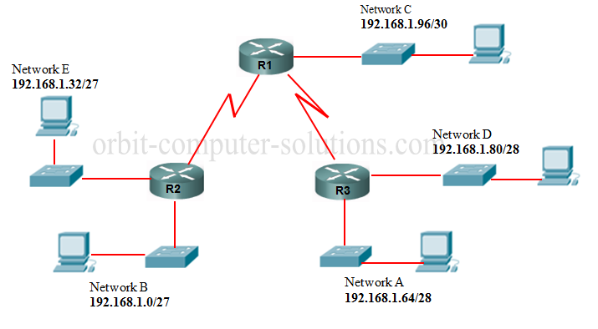

Looking at the diagram, we have three LANs connected to each other with two WAN links.

The first thing to look out for is the number of subnets and number of hosts. In this case, an ISP allocated 192.168.1.0/24. Class C

HQ = 50 host

RO1 = 30 hosts

RO2 = 10 hosts

2 WAN links

We will try and subnet 192.168.1.0 /24 to sooth this network which allows a total number of 254 hosts, I recommend you get familiar with this table below. I never leave home without it!

[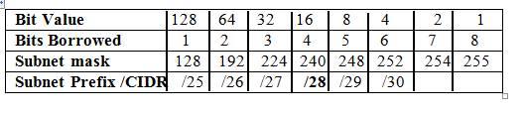](http://www.orbit-computer-solutions.com/VLSM.php)

Let’s begin with **HQ** with 50 hosts, using the table above:

We are borrowing 2 bits with value of 64. This is the closest we can get for 50 hosts.

**192.168.1.0 /26** - Network address

**192.168.1.1** - Gateway address

**192.168.1.2** - First usable address

**192.168.1.62** - Last usable address.

**192.168.1.63** will be the broadcast address (remember to reserve the first and last address for the Network and Broadcast)

**Network Mask 255.255.255.192**  - we got the **192** by adding the bit value from the left to the value we borrowed = 128+64=192

HQ address will look like this 192.168.1.0 /26

Total address space - 192.168.1.2 to 192.168.1.62

**RO1** = 30 hosts

We are borrowing 3 bits with value of 32; this again is the closest we can get to the number of hosts needed.

RO1 address will start from **192.168.1.64** - Network address

Now we add the 32 to the 64 we borrowed earlier = 32+64 = 96

192.168.1.65 - Gateway address

192.168.1.66 - First usable IP address

192.168.1.94 - Last usable IP address

192.168.1.95 Broadcast address

Total address space - 192.168.1.66 –192.168.1. 94

Network Mask 255.255.255.224 - 128+64+32=224 or 192.168.1.64/27

**RO2** = 10 hosts

192.168.1.96 - Network address

We borrow 4 bits with the value of 16. That’s the closest we can go.

**96+16= 112**

192.168.1.97 - Gateway address

192.168.1.98 - First usable address

192.168.1.110 - Last usable address

192.168.1.111 - Broadcast address

Total host address space – 192.168.1.98 to 192.168.1.110

Network Mask 255.255.255.**240** or 192.168.1.96 /28

**WAN links**

We are borrowing 6 bit with value of 4 = **112 + 4 = 116**

WAN links from HQ to RO1 Network address will be 192.168.1.112 /30 :

HQ se0/0 = 192.168.1.113

RO1 se0/0= 192.168.1.114

Mask for both links =  255.255.255.**252** ( we got 252 by adding the bits value we borrowed i.e

124 +64 +32 +16+ 8 +4=252

**WAN Link 2** = 112+4=116

WAN Link from HQ to RO2 Network address = 192.168.1.116 /30

HQ = 192.168.1.117   subnet mask  255.255.255.252

RO2 = 192.168.1.118  Subnet mask 255.255.255.252

|  |  |  |  |
| --- | --- | --- | --- |
| Subnet Prefix / CIDR | Subnet mask | Usable IP address/hosts | Usable IP addresses + Network and Broadcast address |
| /26 | 255.255.255.192 | 62 | 64 |
| /27 | 255.255.255.224 | 30 | 32 |
| /28 | 255.255.255.240 | 14 | 16 |
| /29 | 255.255.255.248 | 6 | 8 |
| /30 | 255.255.255.252 | 2 | 4 |

As I mentioned earlier, having this table will prove very helpful. For example, if you have a subnet with 50 hosts then you can easily see from the table that you will need a block size of 64. For a subnet of 30 hosts you will need a block size of 32.